IUPUI Staff Council

  - Annual Report 2016-2017
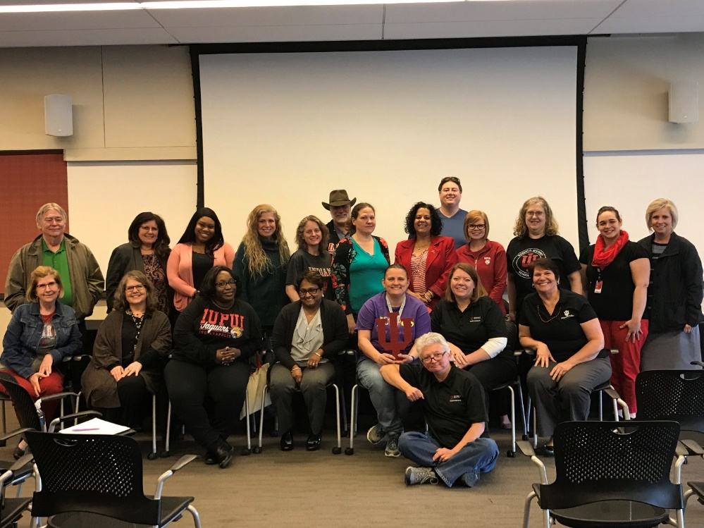

The 2016-17 IUPUI Staff Council Annual Report details the numerous activities and accomplishments of the IUPUI Staff Council. This illustrates a strong testament of the hard work and esprit de corps the Staff Council Representatives, Committee Chairs and members, and Staff Council Executive Committee Officers have while serving the thousands of staff working at IUPUI. It is this dedication and sense of advocacy that allows the IUPUI Staff Council to be the representative voice of staff. It has been my great pleasure to serve the first year of my term as president of Staff Council and the next two years promise to be just as productive and effective.
Representing ALL staff
at IUPUI
for the betterment
of our institution, our city,
our state,
and our nation.
James Klenner, President IUPUI Staff Council

IUPUI Staff Council

Purpose of the Staff Council
The purpose of the Staff Council at Indiana University-Purdue University Indianapolis shall be to represent the staff in the communication processes and the decision making of the University and
- to increase the sense of identity, recognition and worth of each staff member in his/her relationship to the University,
- to identify concerns relating to staff and to seek their solutions,
- to provide a channel of communication for staff with administration and faculty,
- to promote staff development and to recommend policies which aid in retaining highly-qualified personnel,
- to integrate the staff into campus governance and existing University affairs,
- to establish and promote University-wide activities, publications, work-shops, and seminars, and
- to serve as a resource for other schools or units in the development of School or Unit Staff Councils.

IUPUI Staff Council Constitution and Bylaws Article I

2016-2017 Staff Council Executive Committee

Jim Klenner, President
Barb Hanes, First Vice President
Kristy Beach, Second Vice President
Louise Watkins, Corresponding Secretary
Kevin Mouser, Parliamentarian

Members-at-Large
Kaitlin Bell
Caitie Deranek Stewart
Tim Roach
Etta Ward
Alicia Gahimer
Andrew Myers (thru Dec. 2016) and Aimee Brough (Jan. 2017)

Accomplishments

- Held the Annual Staff Council Retreat at the Indianapolis Zoo with Jessica Davis as the keynote speaker.
- Had a booth at the Health and Benefits Fair in October where postcards were collected and prizes were awarded.
- Unit elections were held in April with 39 Staff Council representatives being elected or re-elected to the council.
- Awarded 17 development grants to staff members for professional growth throughout the year.
- Held the Staff Development Mini-Conference on May 26, 2017 with approximately 200 attendees. The Mini-Conference theme was “Star Staff: the Talent Awakens” and Tom McMahon, IU Director of Talent Management, was the keynote speaker.

Civic Engagement
- Held blood drives in November with 58 people donating blood and also in April with 61 people donating blood.
- Took a car load of clothing to the Indianapolis Dress for Success organization.
- Participated with ads and attendance of several diversity related organizations in the community with tables and dinner: Harvey Milk gay awareness dinner for 2 students and 2 staff to attend, Martin Luther King dinner for 2 staff members and 2 students to attend, Cesar Chavez Hispanic dinner for 2 students and 2 staff to attend.

Applauding Excellence
The council gave the following awards through the work of Staff Council Rewards and Recognition Committee:
- Carol D. Nathan Staff Council Scholarship for the 2016-2017 school year to Delana Gifford (Health Sciences) and Jessica Davis (Office of Sustainability)
- Glenn W. Irwin, Jr., M.D. Experience Excellence Award to Merle Illg (School of Liberal Arts) and Pam Ross (School of Nursing)
- Gerald L. Bepko Staff Council Spirit Award to Landon Brothers (Bepko Learning Center), Julie Reagan (School of Informatics), Etta Ward (OVC for Research)
- Nan Bohan Community Engagement Award to Pam Clark (Student Services)

The council also celebrated their own through three internal awards given at the annual retreat. The awards were given by the Staff Council Rewards and Recognition committee as follows:
- Outstanding Committee Chair to Kaitlin Bell (School of Health & Rehabilitation Sciences)
- Outstanding New Member to Allison Wheeler (Student Life)
- Member of the year to Kurt Snyder (School of Medicine)

The council also celebrated staff on their years of service to the IUPUI campus and partnered with Human Resources Administration to host the Chancellor’s Employee Recognition Ceremony.

Continuing the Work

- Will continue to promote the Staff Council through the Health and Benefits Fair.
- Planning blood drives for 2016-2017 with the first one in July, 2016.
- Planning a Staff Council retreat for professional development in July, 2016 at the Indianapolis Zoo.
- Implementation of an Annual Staff Diversity Resource Fair to help raise awareness of the diverse population we have on campus in our students, staff and faculty.

- Looking at several diversity-related panels to bring to the council as well as all staff.
- Will continue to support the annual heritage dinners (Harvey Milk, Martin Luther King, Cesar Chavez, Asian Heritage) as support of diversity, equity and inclusion on campus.
- Lateral move inequities for faculty and staff will continue to be reviewed in coordination with the Vice Chancellor for Finance and Administration for further resolution.
- Continuing discussion on Non-IU staff supervising IU staff and how tenure is interrelated.
- Honoring those who are the Spirit of IUPUI, through the Gerald Bepko Spirit Award, Nan Bohan Community Engagement Award, Multicultural Impact Award, and the Glenn W. Irwin Experience Excellence awards that are given each year at the Chancellor’s Employee Recognition Convocation. We also give a Carol Nathan scholarship to one or two employees who are continuing their education here at IUPUI.
- Are working to revise the grant document to ensure complete understanding by applicants of desired qualifications. A comprehensive communication plan is underway.
- Planning for 2017 Staff Development Mini Conference. Would like to incorporate sponsorship levels for obtaining funding.
- Work with the Asian Heritage Celebration Dinner on campus to promote the mission of the Asian & Pacific American Faculty/Staff Council.

2016-2017 Staff Council Committee Chairs

[Ad hoc] Academic Affairs – Aimee Brough & Jamie Owens
Advisory Committee of Past Presidents – Lee Stone
Bylaws – Tim Roach
Communications –
Diversity, Equity and Inclusion – Andrew Myers & Etta Ward
Faculty Relations – Jim Klenner
Membership – Kristy Beach
Rewards and Recognition – Janet Fulper
Special Events – Kaitlin Bell and Carol Dill
Staff Affairs – Kurt Snyder & Greg Rathnow
[Ad hoc] Staff Development – Caitie Deranek Stewart and Lindsey Mosier
[Ad hoc] Sustainability – Jessica Davis
[Ad hoc] Technology – Scott Orr
Web Adviser – Andrew Myers

