IUPUI Staff CounciL

Annual Report 2017-2018

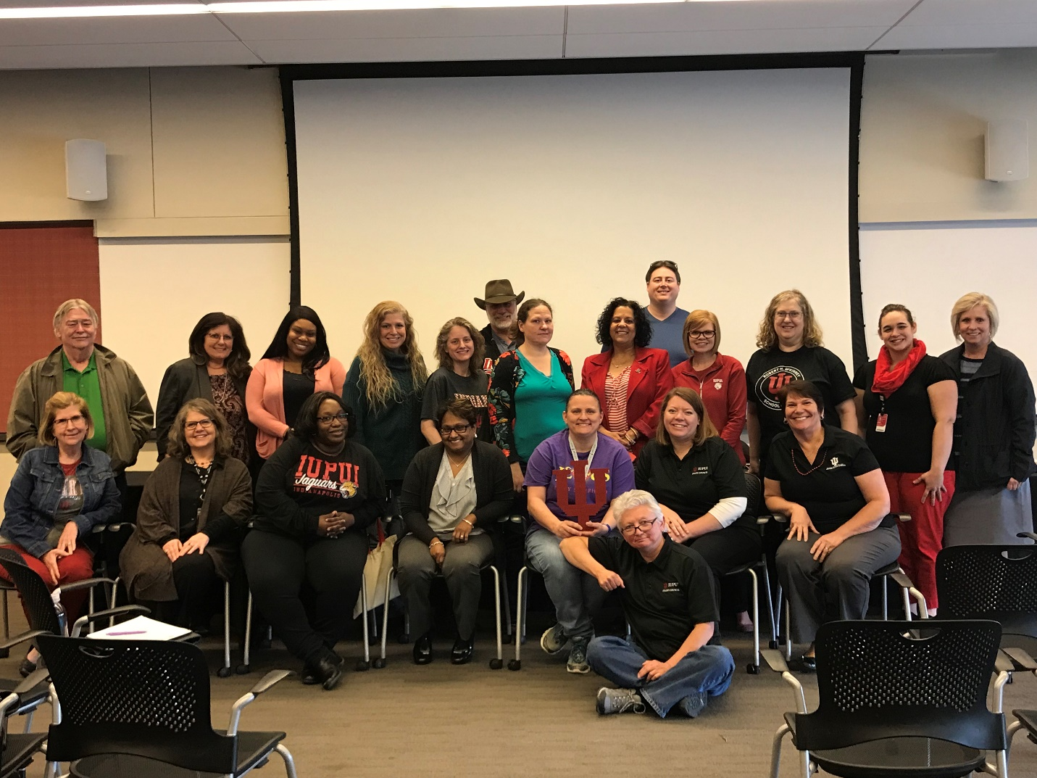
The 2017-18 IUPUI Staff Council Annual Report features the various activities and accomplishments of the Council. The dedication and commitment of the representatives, committee chairs and Executive Committee is apparent in the numerous service projects, an increased presence on campus and the continued support for all staff. It has been a successful first year as the President of Staff Council and am hopeful and confident that this next year will provide more opportunities for professional development, community outreach and campus connections.
Kristy Beach, President IUPUI Staff Council
IUPUI Staff Council
Representing ALL staff
at IUPUI
for the betterment
of our institution, our city,
our state
and our nation.
Representing ALL staff
at IUPUI
for the betterment
of our institution, our city,
our state
and our nation.

Purpose of the Staff Council
The purpose of the Staff Council at Indiana University-Purdue University Indianapolis shall be to represent the staff in the communication processes and the decision making of the University and
- to increase the sense of identity, recognition and worth of each staff member in his/her relationship to the University,
- to identify concerns relating to staff and to seek their solutions,
- to provide a channel of communication for staff with administration and faculty,
- to promote staff development and to recommend policies which aid in retaining highly-qualified personnel,
- to integrate the staff into campus governance and existing University affairs,
- to establish and promote University-wide activities, publications, work-shops, and seminars, and
- to serve as a resource for other schools or units in the development of School or Unit Staff Councils.

IUPUI Staff Council Constitution and Bylaws Article I

2017-2018 Staff Council Executive Committee

Kristy Beach, President
Barb Hanes, First Vice President
Lindsey Mosier, Second Vice President
Beth Chaisson, Corresponding Secretary
Kevin Mouser, Parliamentarian

Members-at-Large

Mansi Singh Tim Roach
Tuan Nguyen Etta Ward
Aimee Brough Alicia Gahimer
Accomplishments

- Held the Annual Staff Council Retreat at Ft. Benjamin Harrison with Jeff Curtis as our keynote speaker, presenting on the Dream Manager concept.
- Had a booth at the Health and Benefits Fair in October where postcards were collected and prizes were awarded.
- Unit elections were held in April with 39 representatives being elected, of which 22 are brand new to the council.
- Staff Council, Finance and Administration and the Office of Diversity, Equity, and Inclusion jointly sponsors the IUPUI Staff Mentoring Program. This project was 1 of 24 Welcoming Campus Innovation Proposals that was granted funding. There are four impact areas this program will focus on: Peer Networks, Career Development, Employee Satisfaction, and Institutional Engagement. These impact areas are centered on the developmental themes Career Capital and Campus Capital.
- Awarded 19 development grants to staff members for professional growth throughout the year.
- Held the Staff Development Mini-Conference in May 2018 with 180 in attendance. The Mini-Conference theme was LEGOS (Lifelong Learner, Exploring, Growing You!, Overcoming Obstacles, and Success) and presenters were all IUPUI Staff. Attendees were also treated to an etiquette luncheon. Most sessions were recorded so that those not able to attend could view via the Staff Council website at their convenience.

Civic Engagement
- Held blood drives in July, October, and April. With 188 units collected.
- Supported Paws Pantry with a yearlong service project of stocking shelves with donated items monthly.
- Organized a winter service project with Holy Family Shelter collecting wish list items to provide help for those in need.
- Participated with ads and attendance of several diversity related organizations in the community with tables and dinner: Harvey Milk gay awareness dinner for 2 students and 2 staff to attend, Martin Luther King dinner for 2 staff members and 2 students to attend, Cesar Chavez Hispanic dinner for 2 students and 2 staff to attend. Also, sponsored the Asian Heritage Fashion Show at the gold level.
- Held a Staff Council Night at a Men’s Basketball Game in the spring.
- Entered a Staff Council team “SC Crew” in the Regatta, placed 24th.

Applauding Excellence
The council gave the following awards through the work of Staff Council Rewards and Recognition Committee:
- Carol D. Nathan Staff Council Scholarship for the 2017-2018 school year to LaVerne Johnson (School of Education) and Andrew Visco (School of Medicine).
- Glen W. Irwin, Jr., M.D. Experience Excellence Award to Casey Windhorst (International Student Services) and Christina Brown (School of Medicine).
- Gerald L. Bepko Staff Council Spirit Award to Lindsey Mosier (School of Medicine), Karley Clayton (Undergraduate Education), and Monica Henry (Graduate Office).
- Nan Bohan Community Engagement Award to Keely Floyd (University College).
The council also celebrated their own through three internal awards given at the annual retreat. The awards were given by the Staff Council Rewards and Recognition committee as follows:
- Outstanding Committee Chair awarded to Rokeena Williams (School of Medicine). Chair of the Staff Development Committee.
- Outstanding New Member awarded to Biannca Yates (Human Resources).
- Member of the Year awarded to Aimee Brough (School of Medicine).

On November 1, 2017, the Council celebrated staff on their years of service to the IUPUI campus and collaborated with Jamie Owens in Finance and Administration to host the Chancellor’s Staff Recognition Ceremony.

Continuing the Work

- Continue to support IUPUI Athletics as a Bronze Level sponsor.
- Will continue to promote the Staff Council through the Health and Benefits Fair.
- Planning blood drives for 2018-2019 the first one was July 18, 2018.
- Planning the annual Staff Council Retreat that will take place in July, 2019 and will incorporate IUPUI’s 50th Anniversary as part of the theme and celebrate the Council’s 40th Anniversary.
- Will continue to support the annual heritage dinners (Harvey Milk, Martin Luther King, Cesar Chavez, Asian Heritage) as support of Diversity, Equity and Inclusion on campus.
- Honoring those who are the Spirit of IUPUI, through the Gerald Bepko Spirit Award, Nan Bohan Community Engagement Award, and the Glenn W. Irwin Experience Excellence awards handed out each year at the Chancellor’s Staff Recognition Ceremony. We also give a Carol Nathan scholarship to one or two employees who are continuing their education here at IUPUI.
- Bylaw rewrite started last year and that will continue until completion.
- The Staff Development Committee updated the application and guidelines process for the Staff Development Professional Grants. To celebrate and recognize the IUPUI staff during the IUPUI 50th Anniversary, we will be awarding 50 grants this academic year!
- Planning for the 2019 Staff Development Mini Conference.

2017-2018 Staff Council Committee Chairs
Academic Affairs – Eric Hamilton
Advisory Committee of Past Presidents – Lee Stone
Bylaws – Tim Roach
Communications – Cathy Zappia
Diversity, Equity and Inclusion – Etta Ward
Faculty Relations – Aaron Fields
Membership – Lindsey Mosier
Rewards and Recognition – Shelanda Graham
Special Events – Aimee Brough and Kaitlin Bell
Staff Affairs – Kurt Snyder
Staff Development – Alicia Gahimer and Rokeena Williams
Sustainability – Liz Whitaker

