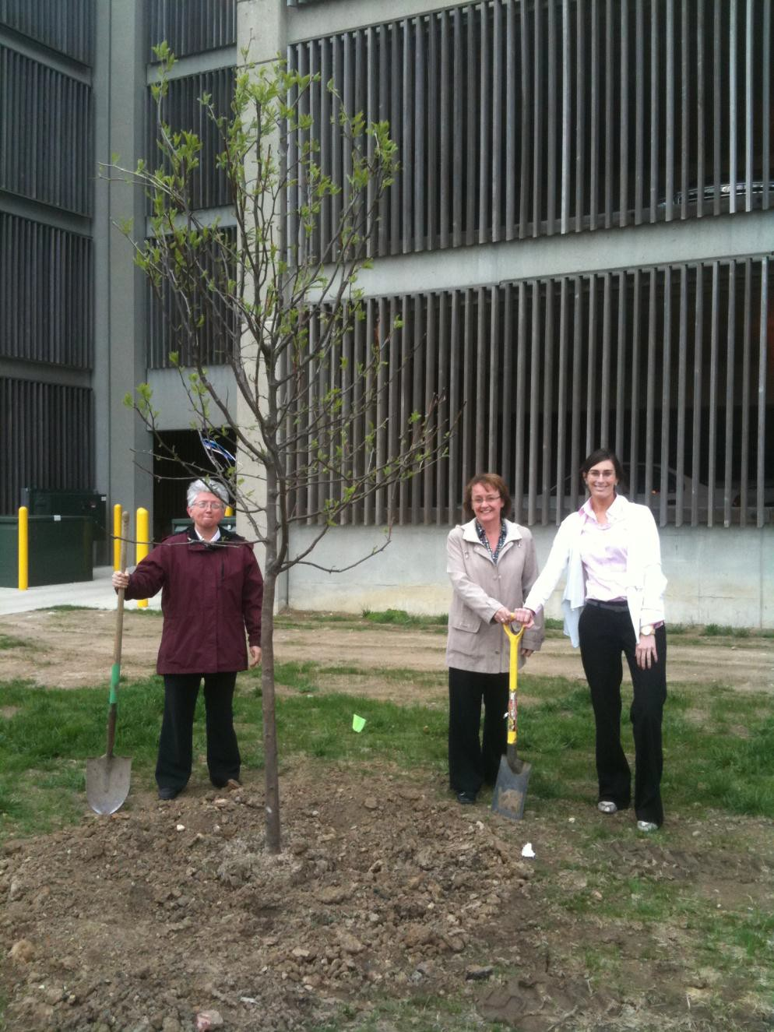

IUPUI STAFF COUNCIL

ANNUAL REPORT 2010-2011

As representatives of all full-time non-union staff on campus, we strive to ensure a staff presence in campus-wide discussion and decision-making. We reach out to fellow staff with valuable information about benefits, human resource policies, and invaluable resources for better working and living. We also volunteer on– and off- campus to make Indianapolis an even better place to work and live.

**1**

|  |  |
| --- | --- |
| IUPUI STAFF COUNCIL  ANNUAL REPORT 2010-2011  PURPOSE OF THE STAFF COUNCIL  The purpose of the Staff Council at Indiana University-Purdue University Indianapolis shall be to represent the staff in the communication processes and the decision making of the University and   * to increase the sense of identity, recognition and worth of each staff member in his/her relationship to the University, * to identify concerns relating to staff and to seek their solutions, * to provide a channel of communication for staff with administration and faculty, * to promote staff development and to recommend policies which aid in retaining highly-qualified personnel, * to integrate the staff into campus governance and existing University affairs, * to establish and promote University-wide activities, publications, work-shops, and seminars, * to serve as a resource for other schools or units in the development of School or Unit Staff Councils.   *IUPUI Staff Council Constitution and Bylaws Article I*  **2010-2011 Staff Council Executive Committee**  Sue Herrell, President  Amanda Shumaker, First Vice President Lee Stone, Second Vice President  Beth Chaisson, Corresponding Secretary Teresa McCurry, Parliamentarian  Members-at-Large:  Margo Foreman Alicia Gahimer Deanna Hart Colleen Rusnak Meagan Senesac  Amanda Shumaker (A replacement member-at-large was not sought when Ms. Shumaker took over as Interim First Vice President.) | KEEPING YOU INFORMED  While 2010 will be remembered for its challenges regarding the budget, the Staff Council is here to keep you informed and will be involved in matters of concern to the staff.  ~ Sue Herrell President |
|  |

**2**

# ACCOMPLISHMENTS

* Disseminated information from Human Resources Administration [courtesy of Interim Assistant Vice Chancellor Martha Bulluck and her staff] at Staff Council meetings about staff development opportunities, Work/Life programming, university benefits, and policy changes.
* Communicated information received from Vice Chancellor Dawn Rhodes, Assistant Vice Chancellor Emily Wren, on topics such as the campus master plan, campus construction projects, parking, budgets, and long-range plans for the university.
* Shared information from the IUPUI Faculty Council about issues of importance to both faculty and staff on this campus.
* Reported the work of the Staff Council at all Faculty Council meetings throughout the year.
* Distributed the Staff Council Newsletter to all full-time staff members on a monthly basis.
* Planned a successful July 16, 2010, staff retreat at the IUPUI Greenwood Learning Center. The theme was “Everyday Creativity” with a development session of the same title by University Human Resources Administration.
* Appointed unit representative positions as vacancies occurred following the 2011 spring election.
* Responded to countless staff inquiries through the Staff Council link (<http://www.surveymonkey.com/s/5M3JBZW>) about health insurance, parking, campus services, food service, and work/life.
* Served on the following campus committees: ADVANCE Internal Advisory Board, Campus Center Advisory Board, Campus Sustainability Committee, Common Theme Committee, External Affairs Coordinating Committee, Healthcare Advisory Committee, Resource Planning Committee, Search Committee for the Assistant Vice Chancellor for Human Resources, and the Search Committee for the Vice Chancellor for Student Life.
* Provided input regarding Policy Review IT-03, Eligibility to use IT Resources.
* Participated in focus groups regarding the Service with Distinction initiative.
* Relocated the Faculty and Staff Council Office to the University Library.
* Considered proposal to conduct Staff Council meetings on a year-round basis.
* Provided topical presentations in an effort to inform IUPUI staff members on such issues as:
  + Health Engagement Program: Dan Rives, Associate Vice President for University Human Resources Administration, and Susan Brewer, University Director for University Healthcare and Welfare Program
  + Performance Management: Bridget Working, Training and Organizational Development Consultant, and Mary Ellen McCann, University Organizational Development Consultant
  + Early Incentive Retirement Plan: Dan Rives and Maurice Smith, University Director of Employee Relations
  + IUPUI IMPACT Campaign: Dee Metaj, Vice President for IUPUI Development
  + Flex Scheduling: Maggie Stimming, Work/Life Program Director
  + Conversations with Chancellor Charles Bantz and Executive Vice Chancellor Uday Sukhatme
  + Sustainability on Campus: Rich Strong, Co-Chair, Sustainability Steering Committee
  + Intergroup Dialogue and Campus Civility Statement: Dan Griffith, Manager of Training and Organizational Development

# CIVIC ENGAGEMENT

The Council reached out to the university and the community by:

* Sponsoring two canoes in the second annual IUPUI Regatta.
* Organizing two campus blood drives (November 2010 and May 2011). A total of 259 units of blood were donated by faculty, staff, and students at IUPUI. The Staff Council partnered with the student group, Circle K, to plan the blood drives.
* Planning a successful holiday celebration for Council members and students at the Center for Young Children [CYC] in December 2010. Donations of winter clothing (hats, gloves, and scarves) were given by the Council members as well as donations from other staff members to assist the Damien Center. CVS Pharmacy donated several wish list items to the CYC.
* Continuing cell phone drive to benefit the Indiana Coalition Against Domestic Violence (ICADV) donating 121 cell phones to the program.
* Participating in the Susan G. Komen Race for the Cure. Together the Staff Council team raised more than $1,700.
* Continuing The Legacy Project (<http://www.iupui.edu/~scouncil/legacy/>) with plantings in the fall, spring, and summer at both campus portals (West and Michigan and New York and Limestone).
* Participating in the August 2011 Race Away from Domestic Violence event sponsored by the ICADV.

Council members also:

* Donated to the IUPUI Campus Campaign.
* Impacted their communities through volunteer work.

# APPLAUDING EXCELLENCE

The Council:

* Awarded the *Carol D. Nathan Staff Council Scholarship* for the 2010-2011 school year to Jolene Kernick and Shannon McCullough.
* Awarded the *Gerald L. Bepko Spirit* Award to Mary Deer, James Klenner, Marilee Taylor, and Thomas Whitcher.
* Awarded the *Nan S. Bohan Community Engagement Award* to Shari Upchurch.
* Awarded the first annual *Multicultural Impact Staff Award* to Josh Manlove.
* Celebrated staff anniversaries for their years of service to the IUPUI campus.
* Established the Ellen Poffenberger Work/Life Fund in honor of the retirement of Assistant Vice Chancellor Ellen Poffenberger (Human Resources). The fund offers general support to enhance and develop work-life programs for the benefit of all IUPUI employees.

# CONTINUING THE WORK

Looking forward, the Council will:

* Sponsor the Third Annual IUPUI Fine Arts and Crafts Fair on October 29, 2011.
* Sponsor a campus blood drive in fall 2011 and spring 2012.
* Continue to support campus beautification through The Legacy Project.
* Support the staff with sponsored workshops as applicable.
* Represent the staff of IUPUI regarding matters of workplace, benefits, and well-being.
* Hold Staff Council meetings on the third Wednesdays from 2:00 to 4:00 p.m. each month.

**3**

# COMMITTEE REPORTS

## Bylaws Committee (Chair: Patti Holt)

Action Items:

* Reviewed suggested changes to the Bylaws. Continuing the work into the 2011-2012 academic year.
* Updated bylaws as approved by vote of the full council.
* Surveyed the Staff Council about holding year-round meetings. Survey response was affirmative; council will review the decision in September 2011.

## Communications Committee (Chair: Meagan Senesac)

Action Items:

* Continued use of a Staff Council Facebook page to encourage membership and get word out regarding events.
* Advertised to appropriate persons and venues regarding scholarships and awards, the Legacy Project, and the Staff Council retreat.
* Send welcome letters to all new employees with information about Staff Council.
* Approved a new format for an electronic newsletter to begin fall 2011.

## (Ad Hoc) Diversity Committee (Chair: Troy Barnes)

Action Item:

* Attended meetings of the Campus Diversity Committee (Ken Durgans, Vice Chancellor for Diversity, Equity, and Inclusion – Chair)
* Included diversity events on the Staff Council and Campus Events Calendars.

## (Ad Hoc) Fine Arts and Crafts Fair Committee (Chairs: Teresa McCurry and Deanna Hart)

Action Items:

* Held the second IUPUI Staff Council Fine Arts and Crafts Fair on October 30, 2010, with sixty-one vendors participating.
* Planned the third IUPUI Staff Council Fine Arts and Crafts Fair to be held on October 29, 2011, in the Campus Center at IUPUI.

## Membership (Chair: Lee Stone and Alicia Gahimer)

Action Items:

* Election of President-Elect (Lee Stone at June 15, 2011, meeting)
* Second Vice President (Alicia Gahimer elected at June 15, 2011, meeting)
* Election of Executive Committee Members At-Large (Kristy Chapman, Patti Holt, and James Klenner elected at June 15, 2011, meeting)
* Election of Unit Representatives (Spring 2011)
* Developed itinerary for Staff Council Awareness Week which included a weekly trivia contest and an information table at four different campus locations; one each week.

Action Items carried over to 2010-2011:

* Facilitation of the August 16, 2011, New Member Orientation
* Review suggested changes to the Bylaws regarding membership and election procedures.

**4**

## Rewards and Recognition (Co-Chairs: Kyle Torgerson, then Sheila Walter and Courtney Wooton)

Awards given to those mentioned under Applauding Excellence.

## Special Events Committee (Co-Chairs: Kristy Chapman and Nancy Gibson)

Action Items:

* Organized Staff Council Retreat on July 29, 2011, at Ft. Benjamin Harrison State Park.
* Planned and held two blood drives in collaboration with Circle K student organization.
* Planned and held Staff Council holiday meeting/reception at the Center for Young Children.
* Continued the work of The Legacy Project to beautify the campus.

Action Items carried over to 2011-2012:

* Staff Council Retreat: July 2012.
* Blood drives planned for October 2011 and April 2012.
* Holiday meeting/reception for Staff Council members at the Center for Young Children. A service project will be planned at the same time.
* The Legacy Project: plantings to take place in the fall, spring, and summer.

## Staff Affairs Committee (Co-Chairs: Alicia Gahimer and Candice Smith)

Action Items:

* Working subcommittees: Health and Safety, Transportation/Parking, Human Resources, and Benefits.
* Working with University Human Resources to bring better awareness of performance management to all units at IUPUI.
* Campus Safety Committee is concentrating on bicycle safety and is constructing a bike safety brochure.
* Miscellaneous issues such as parking pass increases, health engagement issues, pedestrian safety around the ITIC building and new garage, flexible work schedules, employee fee courtesy, and the non-compliance of the campus smoking policy

## [Ad Hoc] Web Committee (Coordinator: Karen Lee)

Action Items:

* Continued monitoring of the Staff Council Website to be sure it is always current.

**2010-2011 Staff Council Committee Chairs**

Bylaws – Patti Holt

Communications – Meagan Senesac Membership – Lee Stone

(Ad Hoc) Nominations – Lee Stone

Rewards and Recognition – Kyle Torgerson, then Courtney Wooton and Sheila Walter Special Events – Kristy Chapman and Nancy Gibson

(Ad Hoc) Diversity – Gary Curto

Staff Affairs – Alicia Gahimer and Candice Smith (Ad Hoc) Web – Karen Lee

**5**