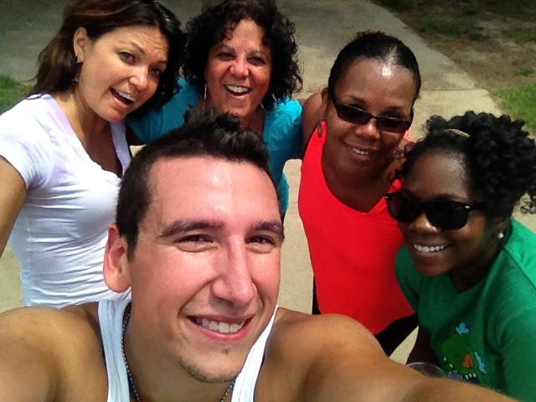

IUPUI STAFF COUNCIL

# ANNUAL REPORT 2015-2016

The 2015-16 IUPUI Staff Council Annual Report details the numerous activities and accomplishments of the IUPUI Staff Council. This illustrates a strong testament of the hard work and esprit de corps the Staff Council Representatives, Committee Chairs and members, and Staff Council Executive Committee Officers have while serving the thousands of staff working at IUPUI. It is this dedication and sense of advocacy that allows the IUPUI Staff Council to be the

Representing

**ALL** staff

at IUPUI

for the betterment

of our institution, our city,

our state,

and our nation.

representative voice of staff. It has been my great pleasure to serve the first year of my term as president of Staff Council and the next two years promise to be just as productive and effective.

James Klenner, President IUPUI Staff Council

IUPUI STAFF COUNCIL

# ANNUAL REPORT 2015-2016

PURPOSE OF THE STAFF COUNCIL

The purpose of the Staff Council at Indiana University-Purdue University Indianapolis shall be to represent the staff in the communication processes and the decision making of the University and

* to increase the sense of identity, recognition and worth of each staff member in his/her relationship to the University,
* to identify concerns relating to staff and to seek their solutions,
* to provide a channel of communication for staff with administration and faculty,
* to promote staff development and to recommend policies which aid in retaining highly-qualified personnel,
* to integrate the staff into campus governance and existing University affairs,
* to establish and promote University-wide activities, publications, work- shops, and seminars, and
* to serve as a resource for other schools or units in the development of School or Unit Staff Councils.

*IUPUI Staff Council Constitution and Bylaws Article I*

**2015-2016 Staff Council Executive Committee**

Jim Klenner, President

Barb Hanes, First Vice President Kristy Beach, Second Vice President

Louise Watkins, Corresponding Secretary Kevin Mouser, Parliamentarian

Members-at-Large Kaitlin Bell

Caitie Deranek-Stewart Andrew Myers

Tim Roach Etta Ward

Cortnee Yarbrough

Accomplishments

* + Held the Annual Staff Council Retreat at the Indianapolis Museum of Art with Kim Kirkland as the keynote speaker.
  + Had a booth at the Health and Benefits Fair in October where postcards were collected and prizes were awarded.
  + Created liaisons to diversity related committees to become aware of and support their initiatives. Established relationships with other individuals and groups concerned with DEI across campus, including the Chancellor’s Diversity Cabinet.
  + Provided Diversity Speaker to Staff Mini Conference in June, 2016.
  + Faculty and Staff Relations Committee looked at TIME Timekeeping System to determine if all campuses were synchronous and/or asynchronous reporting. Recommended the Chancellor do an audit of this.
  + Unit elections were held in April with 42 representatives being elected, of which 28 are brand new to the council.
  + Started a mentoring program for new members with the April election of 28 new council members. They will be paired with an experienced council member for the first year of service to make sure they know about meetings, are connected with the council, to help with networking opportunities and are general information counselors about the council. There will also be an orientation session for all new members at the Retreat in July, 2016.
  + Awarded 15 development grants to staff members for professional growth throughout the year.
  + Held the Staff Development Mini-Conference in June, 2016 with 211 in attendance. We were also able to stream the conference this year but do not know how many were able to join that way.

Civic Engagement

* + Held blood drives in November with 58 people donating blood and also in April with 61 people donating blood.
  + Took a car load of clothing to the Indianapolis Dress for Success organization.
  + Participated with ads and attendance of several diversity related organizations in the community with tables and dinner: Harvey Milk gay awareness dinner for 2 students and 2 staff to attend, Martin Luther King dinner for 2 staff members and 2 students to attend, Cesar Chavez Hispanic dinner for 2 students and 2 staff to attend.

Applauding Excellence

The council gave the following awards through the work of Staff Council Rewards and Recognition Committee:

* + Carol D. Nathan Staff Council Scholarship for the 2016-2017 school year to Michael Golub (Engineering & Technology) and Robert Lawson (Pharmacology & Toxicology)
  + Glenn W. Irwin, Jr., M.D. Experience Excellence Award to Jane Alexander (Science), Mary Gibson Upton (International Affairs), and Teresa McCurry (University Library)
  + Gerald L. Bepko Staff Council Spirit Award to Alicia Gahimer (Research Administration), Mansi Singh (Community Engagement), Eric Teske (Student Life)
  + Nan Bohan Community Engagement Award to Karen Metzger (Athletics)
  + Multicultural Impact Staff Award to Cristina Caputo (University College) and Etta Ward (Vice Chancellor for Research Administration)

The council also celebrated their own through three internal awards given at the annual retreat. The awards were given by the Staff Council Rewards and Recognition committee as follows:

* + Outstanding Committee Chair to Kristy Beach (Dentistry) and Cortnee Yarbrough (School of Public and Environmental Affairs)
  + Outstanding New Member to Kurt Snyder (Medicine/Continuing Education)
  + Member of the year to Lindsey Mosier (Law)

The council also celebrated staff on their years of service to the IUPUI campus and partnered with Human Resources Administration to host the Chancellor’s Employee Recognition Ceremony.

Continuing the Work

* + Will continue to promote the Staff Council through the Health and Benefits Fair.
  + Planning blood drives for 2016-2017 with the first one in July, 2016.
  + Planning a Staff Council retreat for professional development in July, 2016 at the Indianapolis Zoo.
  + Implementation of an Annual Staff Diversity Resource Fair to help raise awareness of the diverse population we have on campus in our students, staff and faculty.
  + Looking at several diversity-related panels to bring to the council as well as all staff.
  + Will continue to support the annual heritage dinners (Harvey Milk, Martin Luther King, Cesar Chavez, Asian Heritage) as support of diversity, equity and inclusion on campus.
  + Lateral move inequities for faculty and staff will continue to be reviewed in coordination with the Vice Chancellor for Finance and Administration for further resolution.
  + Continuing discussion on Non-IU staff supervising IU staff and how tenure is interrelated.
  + Honoring those who are the Spirit of IUPUI, through the Gerald Bepko Spirit Award, Nan Bohan Community Engagement Award, Multicultural Impact Award, and the Glenn W. Irwin Experience Excellence awards that are given each year at the Chancellor’s Employee Recognition Convocation. We also give a Carol Nathan scholarship to one or two employees who are continuing their education here at IUPUI.
  + Are working to revise the grant document to ensure complete understanding by applicants of desired qualifications. A comprehensive communication plan is underway.
  + Planning for 2017 Staff Development Mini Conference. Would like to incorporate sponsorship levels for obtaining funding.
  + Work with the Asian Heritage Celebration Dinner on campus to promote the mission of the Asian & Pacific American Faculty/Staff Council.

2015-2016 Staff Council Committee Chairs

Academic Affairs – Aimee Brough

Advisory Committee of Past Presidents – Lee Stone Bylaws – Kevin Mouser

Communications – Liz Rybak

Diversity, Equity and Inclusion – James Bellamy Faculty Relations – Jim Klenner

Membership – Kristy Beach

Rewards and Recognition – Barb Hanes Special Events – Kaitlin Bell and Carol Dill Staff Affairs – Lyndy Kouns and Kurt Snyder

Staff Development – Caitie Deranek Stewart and Lindsey Mosier Sustainability – Jessica Davis

Technology – Scott Orr

Web Adviser – Andrew Myers