

# Staff Council Minutes January 15, 2025 ~ 2:00-4:00 p.m. University Library Lilly Auditorium

**Members and Guests Present:** Leslie Alberts, Sadiya Ali, Connie Anoskey, Alan Beard, Chad Beckner, Thora Berndt, Brayden Bridgeman, Aaron Buck, Beth Chaisson, Crystal Clark, Mindy Cooper, Jeff Dawn, Melissa Decker, Tricia Edwards, Connie Ely, Kevin Fryling, Alicia Gahimer, Jennifer Gilles, Roland Graham, Lauren Gronke, Lindsey Heinzman, Nick Hyllested, Kim Johnson, LaVerne Johnson, Todd Kirk, Anne McGee, Mercedes O’Connor-Gosser, Amber Phillips, Kris Powell, Jamunabai Prakash, Matthew Radican, Lindsey Sanner, Huma Siddiqui, Emily Skoniecke, Ellise Smith, Anita Snyder, Heather Staggs, Oliva Stoner, Heather Wagoner, Laurie Welty, DoMonique Brock, Camy Broeker, Katie Bucko, Megan Chester, Jeff Creasser, Ashley Eppich, Ying Feng, Shonda Gladden, Jay Gladden, Kate Grimm, Lisa Hastings-Smith, Faith Herman, Keeley Higley, Angie Hill, Carrie Hopf, Allison Hughes, Emily Keen, Jennifer Mahoney, Anne Mitchell, Cliff Morlan, Gina Nicholson, Nina Onesti, Latosha Rowley, Julia Sanders, Jackie Turner, PJ Woolston

**Members Excused:** Todd Grooten, Jill Henry, Madeline Jones, Natalie Lin, Jennifer McChristian, Summer Rozear, Anita Sale, Yolanda Taylor, Jordan Wheatley, Catherine Zappia

**Members Absent:** Jesse Beck, Ailish Evans, Jesse Lambertson, Tammy Leone, Paige Smith, Dillon Waggoner, Dionna Weatherly

# Agenda Item I: Welcome and Call to Order

Heather Staggs, *President*, [hstaggs@iu.edu](mailto:hstaggs@iu.edu)

IU Indianapolis Staff Council President Heather Staggs called the meeting to order.

# Agenda Item II: [Action Item] Adoption of the Order of Business for the Day

Heather Staggs

The agenda was adopted as the Order of Business for the Day.

# Agenda Item III: [Action Item] Approval of Minutes of the December 18, 2024, SC Meeting

Heather Staggs

With no objections, the December 18 SC meeting minutes were approved.

# Agenda Item IV: Update from Provost and Executive Vice Chancellor

Jay Gladden, *Provost and Executive Vice Chancellor*, [jamglad@iu.edu](mailto:jamglad@iu.edu)

* Personal and professional background. Dean of Physical Education 2009, Assoc. Vice Chancellor for Undergraduate Education 2017, Assoc. Vice President for Learning Technologies (UITS) 2021, Interim Exec. Vice Chancellor September 2023, and in 2024 became the Inaugural Provost and Executive Vice Chancellor.
* Role oversees campus academic operations: teaching and learning, academic units, undergrad and grad programs, library, faculty development and promotion.
* Shared some projects related to [IU Indy 2030 Strategic Plan](https://indianapolis.iu.edu/about/strategic-plan/)
  + Student success
    - Improving graduation rates. 55-58% of our students graduate in 6 years. To help improve we are doing:
      * Proactive advising. Focus on first year students.
      * First time, fulltime student. 85% goal for 1 year student retention, currently 73%.
      * Student success in 100 and 200 level classes.
  + Research and creative activity
    - Created 2 new interdisciplinary centers.
      * Convergent Biosciences and Technologies Institute
      * The Institute for Human Health and Well-Being
  + Service to our State and Beyond
    - Expand our contribution to workforce development
    - Co-op program with Eli Lilly and Company partnering with 3 of our schools

Question and Answer

* How do you see the non-academic sides contributing to the overall mission? Health and wellness, having physical places that people take pride in, one interaction with one student can change the student’s trajectory.
* Indiana Bioscience Research – What will be the connections with that research area and our campus be? Partner in IU Lab building, goal to be tightly intertwined and will lead to collaborations.

# Agenda Item V: Enrollment Management presentation

PJ Woolston, *Vice Chancellor for Enrollment Manage*[*ment*, pjwool@iu.e](mailto:pjwool@iu.edu)du

* State of enrollment
  + All IU: New Students
    - New beginner students +3.5%
    - All campuses showing an increase in beginner students: 4% increase in undergrad and 0.6% in grad
  + Indianapolis Funnel: New Beginners
    - Applications +22.6%
    - Admitted Students +15.9%
    - Deposits +13.3%
    - Enrolled +9.5%
  + Underrepresented Minority Enrollment
    - Indianapolis +9.6%
    - Continued, consistent growth =14%
    - Beginner class +24.9%
    - Overall: Black/African American +13.7% and Hispanic/Latino +9.6%
* Enrollment growth imperative
* Challenges to enrollment growth
  + Demographic cliff (national)
  + College-going rate (Indiana)
  + Value proposition
  + FAFSA rollout
  + Realignment (institutional)
* What can I do?
  + Everyone is a recruiter… but everyone has a distinct role!
  + Ask yourself
    - Where do you interact with students?
    - How do you “rep the school”?
    - How do you talk about the school?
  + Leveling up
    - Identify point of intersection with new student recruitment
    - Select a gap you can fill
    - Determine an effective way to the fill that gap
    - Engage a team of collaborators
    - Launch!
  + Next steps
    - Focus on students
    - Rep the school
    - Level up your recruitment
    - How can you help students have an actual vision of what it’s like to be a student here?
    - Collaborate with Admissions: Bring us the ideas you want to launch!

Question and Answer

* How will we help faculty and staff increase student enrollment? Staff will need support to provide students with the best experience. We would love for staff to come explore recruiting ideas with us.
* How do we do the work as staff and be supported the work with legislative changes? Encouraged us to review President Whitten’s response to legislative changes.
* New high school diploma requirements in Indiana. We are watching very closely and making sure that the college enrollment option does not fall off.
* What are we doing to reach out to military students? There had been talk about a military recruiter, is that still being discussed? Not currently talking about a military specific recruitment. We are thinking about this on many levels and how to make

seamless admissions for this student base.

# Agenda Item VI: Report from the President

Heather Staggs

* Welcome Shane Bennett and Olivia Stoner to our meeting!
* Blood drive scheduled for today in Campus Center TV Lounge from 10a-4p is almost full. Information was communicated through SC email list, social media, events calendar.

Future dates also shared through email for upcoming drives on

* + March 26, 2025 – Campus Center Atrium
  + May 21, 2025 – Campus Center TV Lounge
  + November 25, 2025 - Campus Center TV Lounge
* Reminder the February 2025 meeting will be held in-person only when we will get to hear from Chancellor Ramchand. The meeting location will change. We have requested to be back in the UL Lilly Auditorium.

# PROFESSIONAL DEVELOPMENT & INVOLVEMENT OPPORTUNITIES

**IU Indianapolis Events Calendar** <https://events.iu.edu/indianapolis/>

Events are being held virtually unless otherwise stated. This is not a comprehensive list of all available offerings on the events calendar.

* 1/21 11a-12p - Performance at IU: Annual Conversation Training for Leaders
* 1/22
  + 1-2p - CareTalks: Child Card & Parenting: Raising Well Balance Children
  + 2-3p - Performance at IU: Annual Conversation Training for Staff
* 1/27 – Healthy IU: Mindful Self-Compassion – Spring 2025 – 6 dates 11a-12p weekly
* 1/28
  + 12-12:45p – Financial Wellness: Create a Budget and Build Emergency Savings
  + 1-2p – CareTalks: Your Healthy Lifestyle: Eat Your Way to a Healthy Year
* 1/30 (6:30-8:30p) - 1/31 (8a-4:30p) Symposium: Frederick Douglass and Benjamin Harrison Confront the Late 19th Century Problems of Race and Expansion at Madame Walker Theatre – Symposium investigates the intertwined legacies of racism and imperialism in late nineteenth-century America, spotlighting the lives of President Benjamin Harrison and Frederick Douglass.
* 2/3 9:30-11:30a Campus Center 450 – Brunch with the Chancellor – An opportunity to discuss campus concerns with members of the IU Indianapolis Black Faculty and Staff Council, campus administration, and Chancellor Ramchand.
* 2/4 1-4p – HealthyIU: Anxiety at Work: Training for People Leaders
* 2/5 9:30-11am Introduction to Lean Process Improvement
* 2/6 1-2p – CareTalks: Emotional Wellness: Relaxation to Reduce Stress
* 2/11
  + 12-1p Faculty & Staff Mentoring Dialogues in UL 1116
  + 1-2p – CareTalks: Disability & Neurodiversity: Caring for Your Older Child with Disabilities
* 2/12 1-2p – CareTalks: Financial Wellness: Tax Tips

# Intercultural Competence Certificate

*The* [*Intercultural Competence*](https://global.iu.edu/resources/staff/intercultural-competence/?_gl=1%2A1mv4b4n%2A_gcl_au%2AMjI5NTMzODEzLjE3MzA3Njg0NzIuNjQ5NTU3NDc3LjE3MzQwMzEyNjUuMTczNDAzMTI2NA..%2A_ga%2AMTg3NTQyNjAxMy4xNzMwNzY4NDcy%2A_ga_61CH0D2DQW%2AMTczNjg2NjgwMy4xMTEuMS4xNzM2ODY4ODIyLjYwLjAuMA) *certificate is a professional development opportunity for IU employees seeking to expand their understanding of the complexities of intercultural communication and collaboration.*

Curriculum

All courses will include an applicability component. Sessions will be a mix of virtual events and reading assignments that can be completed on your own. Feel free to attend a smaller number of sessions without obtaining a certificate. Session categories are: Knowledge, Skills, and Attitude. Sessions are held in Canvas or on Fridays virtually with the first opportunity starting on February 14 or in Canvas.

Complete 4 sessions to earn the certificate.

* Complete at least one session from each category listed below.
* You can also attend an intercultural event and submit a [short impact paragraph](https://global.iu.edu/machform/view.php?id=110288) (writing prompts provided) in lieu of one session.

# Campus Read – Spring 2025

Registration Open

The Campus Read program is open to all faculty and staff, including IU affiliates.

The Spring 2025 cohort will offer two programs:

* Faculty and Staff track – “Do the Work! An Antiracist Activity Book”.
* Faculty and Lecturer track – “Inclusive Teaching: Strategies for Promoting Equity in the College Classroom”.

Groups will meet for 1 hour via Zoom beginning the week of February 3. Copies of the books are provided. All are encouraged to participate. You will register for the exact meeting dates and times. Program information was communicated out through Staff Council’s email listserv which includes registration links. We will send that communication out again before the program starts.

# STAFF MILESTONES

Each month we will highlight staff from one of the milestones. As a reminder all staff milestones for the month are listed on the Staff Council website under the Staff Recognition header.

* 5 years - 18 people
* 10, 15, 20 years – 5 people
* 25 years – 1 person
* 35 years – 2 people
* 40 years – 1 person

This month we will highlight our staff with 5 years of service. Here are some historical events from January 2020.

1. Lara Boulton, Neuroscience Administration
2. Bridget Brian, PED - Immunotherapy Basic Research
3. Erick Collier, Campus Facility Services
4. Kelsey Cox, Pathology and Laboratory Medicine
5. Patrick Gillespie, Molecular Genetics
6. Angela Hill, Ruth Lilly Medical Library
7. Aaron Hodge, UITS Health Technology Support
8. Jena Lane, PED - Child Protection Program
9. Katie Livingston, Pediatric Dentistry
10. Maria Martinez, Cancer Center
11. Michael Monaghan, UITS Health Technology Support
12. April Name, VP Communications & Marketing
13. Kari Romine, School of Science
14. Kelli Schaefer, International Affairs
15. Denise Spellman, Campus Facility Services
16. Amy Toone, IUSM - Evansville
17. Caitlin VanOverberghe, Medicine - Chairman's Office
18. Jennifer Watson, School of Law

Events:

* + Duke and Duchess of Sussex announce their plan to step back as senior royals and work towards being financially independent.
  + 74 time Jeopardy champion, Ken Jennings, wins the “greatest of all time” tournament.
  + Former Sacramento State softball player Alyssa Nakken becomes first woman to hold a coaching position as MLB staff when named assistant by the San Francisco Giants.
  + Top movie was “Bad Boys for Life” which grossed $135,561,888 at opening and

$206,305,244 total.

* + 2020 started with Mariah Carey’s “All I Want for Christmas is You” at the number 1 spot. It had the top spot for 3 weeks and became the first time an artist was ranked number one on the charts in 4 different decades. The week of January 11th, Post Malone’s “Circles” become number one.

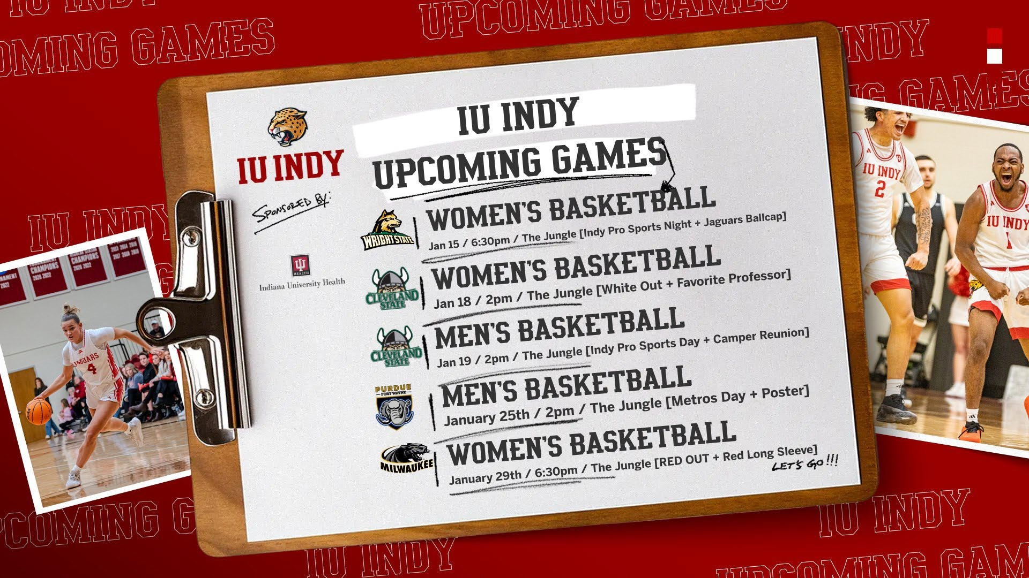

# Agenda Item VII: Update from the Vice Chancellor for Finance and Administration

Camy Broeker, *Vice Chancellor for Finance and Administration,* [cbroeker@iu.edu](mailto:cbroeker@iu.edu)

* + Bookstore pop-up shops at basketball games.
  + Dining
    - Tower Dining – Faculty and staff can eat there as well. Opportunity to connect with students and different food variety.
      * Global Food Experiences every Wednesday and rotating specials at Chef’s Table.
      * Celebration for new Lunar Year.
    - Updating Chancellor’s menu end of January.
    - New snack mobile carts across campus.
    - The Den, cinnamon roll pancakes.
    - Live music with Tea’s Me Cafe.
  + Summer Day camp registrations open February 3rd.
  + Thank a Grounds worker for their work with making campus accessible for us. Can thank a Campus Facility Services team member on their website. Call 317-278-1900 for assistance.
  + If you see a door open, please close it.
  + Project updates
    - Feb wrap-up – Lockefield Garage ext.
    - Eskenazi Hall project going through the Spring.
    - Chilled water going on currently.
    - Dental School renovations.
    - Athletics and Convocation Center – Groundbreaking Feb. 2025. planned opening 2026
    - STEM Annex – Break ground approximately the same time.
    - Purdue building will break ground in April and complete 2027.
  + Basic premise – IU will not close for inclement weather due to our support of hospitals,

academics, etc.

# Agenda Item VIII: Report from Human Resources

Anne Mitchell, *Senior Human Resources Director,* [amitch29@iu.edu](mailto:amitch29@iu.edu)

* + Celebrate Martin Luther King Jr. Day. Hope you can participate in celebratory events and/or personal learning.
  + HR Business Partner position open for Lilly School of Philanthropy.
  + Adverse weather policy – balance safety with work responsibilities.
  + Gallup MyVoice survey – Results will be coming out soon.
  + Performance at IU – IU Indianapolis will be doing annual performance conversations this year.
  + Encourage participating in the reading group. *Do the Work!* book is very meaningful.
  + Staff Mentoring alumni program – the people here are what makes our campus go. I encourage you to remind yourself of the power you have to help and support others.

# Agenda Item IX: [Information Item] Tech Talk: Copilot Activity

Tom Mason, *Principal Microsoft Adoption Consultant, UITS*, [tlmason@iu.edu](mailto:tlmason@iu.edu)

* + What is Gen AI?
    - Type of AI able to create data based on patterns.
    - Trained on large amounts of data.
    - Primary a predictive engine
    - Data = text, images, sound, video, code, etc.
  + Generative AI tools at IU
    - Microsoft Copilot
    - Microsoft 365 Copilot
    - Adobe
  + Generative IU uses
    - Content creation
    - Information location
  + Talking to AI – Context, Output, Role, Example
  + Working with AI – Iterative process, break down complex tasks, creativity and experimentation, and adapt
  + Microsoft 365 Copilot demonstration
  + Ethical considerations – intellectual property, privacy, bias and fairness, and authenticity
  + Training resources
    - Canvas modules
    - Teaching.IU
    - Digital Gardener
    - LinkedIn Learning
  + Try it: <https://go.iu.edu/8s1T>

# Agenda Item X: Membership Ad Hoc Committee

Beth Chaisson

Item postponed to February 19, 2025 meeting.

# Agenda Item XI: Question and Answer Period

None

# Agenda Item XII: Unfinished Business

None

# Agenda Item XIII: New Business

None

# Agenda Item XIV: [Action Item] Final Remarks and Adjournment

Heather Staggs

The meeting was adjourned. The next Staff Council meeting will be February 19, 2025, in Campus Center 309 or on Zoom, [**https://iu.zoom.us/j/84849043840**](https://iu.zoom.us/j/84849043840)