

Staff Council Minutes

March 19, 2025 ~ 2:00-4:00 p.m.

University Library Lilly Auditorium

**Members and Guests Present:** Leslie Albers, Sadiya Ali, Jordan Barnett, Alan Beard, Chad Beckner, Thora Berndt, Laurie Bickell, Brayden Bridgeman, Camy Broeker, Tasheena Brown,  Aaron Buck, Beth Chaisson, Crystal Clark, Mindy Cooper, Phaedra Corso, Jeff Dawn, Colesha Dawson, Lilly Delva, Tricia Edwards, Connie Ely, Kevin Fryling, Alicia Gahimer, Cindy Gil, Jennifer Gilles, Lauren Gronke, Alison Hughes, Nick Hyllested, Kim Johnson, LaVerne Johnson, Madeline Jones, Todd Kirk, Betty Klein, Jennifer Mahoney, Anne Mitchell, Amber Phillips, Kris Powell, Jamunabai Prakash, Tammy Pressler, Matthew Radican, Latha Ramchand, Anita Sale, Lindsey Sanner, Elise Seidel, Huma Siddiqui, Emily Skoniecke, Ellise Smith, Paige Smith, Anita Snyder, Heather Staggs, Oliva Stoner, Yolanda Taylor, Dillon Waggoner, Dionna Weatherly, Laurie Welty, and Andrea Zeek

**Members Excused:** Jesse Beck, Susan Corrie-Franklin, Melissa Decker, Ailish Evans, Roland Graham, Todd Grooten, Jill Henry, Tammy Leone, Natalie, Lin, Anne McGee, Heather Wagoner, and Jordan Wheatley

**Members Absent:** Connie Anoskey, Angie Harmon, Lindsay Heinzman, Erika Leary, Mercedes O’Connor-Gosser, Summer Rozear, and Catherine Zappia

# Agenda Item I: Welcome and Call to Order

Heather Staggs, *President*, [hstaggs@iu.edu](mailto:hstaggs@iu.edu)

IU Indianapolis Staff Council President Heather Staggs called the meeting to order.

# Agenda Item II: [Action Item] Adoption of the Order of Business for the Day

Heather Staggs

The agenda was adopted as the Order of Business for the Day.

# Agenda Item III: Greetings and Address from Chancellor’s Office

# Latha Ramchand, *Inaugural Chancellor of IU Indianapolis and Executive Vice President of Indiana University*, Chancellor’s Office, [chancllr@iu.edu](mailto:chancllr@iu.edu)

A conversation with Chancellor Ramchand was held to discuss our shared commitment to our people and ensuring that everyone feels supported and valued.

**Agenda Item IV: [Information Item] Healthy IU Presentation**

Betty Klein, *Health and Wellness Specialist, Healthy IU*, IU Human Resources, [bkklein@iu.edu](mailto:bkklein@iu.edu)

Presentation included “Be a Self-Care Rockstar, Managing Anxiety”

* Self-Care is not selfish
* Self-Care = Self-Compassion
* Dimensions of Wellness
  + Physical
  + Occupational
  + Social
  + Emotional
* HealthyIU Offerings
  + Work + Life Social Connection Groups
  + Spring 2025 Programs
  + CareTalks
  + Mental Well-Being
  + Workplace Mental Health site
  + Partners: Care, Weight Watchers, SupportLinc, Marathon Health, nutrition counseling
* Negative Bias
* Beyond Anxiety
* Take Aways
  + Practice self-compassion
  + Prioritize health – sleeping and eating well
  + Consider digital detox
  + Connect with nature and tribe
  + Get support
  + Be creative to overcome anxiety
  + Find your purpose

**Agenda Item V: [Information Item] Research Presentation**

Dr. Phaedra Corso, *Associate Vice President for Research Indiana University and Vice Chancellor for Research, IU Indianapolis*, Office of the Vice Chancellor for Research, [pcorso@iu.edu](mailto:pcorso@iu.edu)

Presentation included “IU Research Overview, Understanding IU’s Research Enterprise”

* Scope of IU Research
  + Research Development & Funding Support
  + Grant Administration & Compliance
  + Commercialization & Innovation
  + Research Security & Integrity
  + Research Centers, Collections, and Partnerships
* Convergent Bioscience and Technology Institute (CBATI)
* Institute for Human Health and Wellbeing (H2W)
* Integrated Nanosystems Development Institute (INDI)
* Indianapolis Arts and Humanities Institute (IAHI)
* Research at IU Indy
  + Hydrocephalus Research Center
  + Ray Bradbury Center
  + Center for the Study of Religion & American Culture
  + Blockchain Technology
  + AI Music Improvisation program
* Coming soon
  + New STEM Lab building
  + The Indiana University Launch Accelerator for Biosciences (IU LAB)
    - The Academic Gateway
    - The Futures Center
    - The IU Innovates Bio Start-Up Center
    - The Public-Private Partnerships (P3) Center
    - The Joint Center of Excellence for Point of Care Precision Medicine
    - The Translational Bio Center

# Agenda Item VI: Report from President

# Heather Staggs

# A quick overview was provided to allow time for meeting presenters. Professional development and staff recognition items are included.

* There is still time to register and a few slots remaining for our next blood drive on March 26 between 10am-4pm in the Campus Center Atrium. The registration link was emailed out and is available on the IUI Events Calendar.

Upcoming blood drives are

* + May 21, 2025 – Campus Center TV Lounge
  + November 25, 2025 - Campus Center TV Lounge
* Deadline for next Staff Council Professional Development Grant applications is April 1.
* With our robust schedule for today, we will include professional development opportunities and staff milestones in the meeting minutes.
* We will now receive our Athletics update from Lauren Gronke!

**PROFESSIONAL DEVELOPMENT & INVOLVEMENT OPPORTUNITIES**

**IU Indianapolis Events Calendar**  <https://events.iu.edu/indianapolis/>

* 3/20 10-11a – Research session: Health Informatics
* 3/25 12-5p Sidney & Lois Eskenazi Hall- Herron Spring Market
* 3/26 10-11a Taylor Hall Accessibility: Storying Centers for Independent Living in History & Community
* 4/9 9a-3p University Tower – 7th Annual Supervisor Summit – Covers topics geared towards supervisors of student employees.
* Campus Sustainability Implementation [Series](https://cpf.iu.edu/climate-action/news/implementation-series-spring-25.html?_gl=1*10zd4u7*_gcl_au*OTk3NjM5MDk1LjE3Mzk4MjE5NzAuODQwNjAzODk0LjE3NDExMTYyNDguMTc0MTExNjI2Mw..*_ga*MTg4MTg4OTMzMC4xNzM5MjEyNTE3*_ga_61CH0D2DQW*MTc0MTcyOTExMy4yNDMuMS4xNzQxNzI5MTE1LjU4LjAuMA..)
  + March 28 - Tour: IU Surplus Stores, [Indianapolis](https://events.iu.edu/sustainability-indianapolis/event/1780856-campus-sustainability-implementation-series) (In-person only),
  + April 4 - Financing Sustainability
  + April 11 - Panel: Major Challenges to Implementation (Virtual only)
  + April 18 - IU Tree Inventory & Green Infrastructure
  + April 22 - Sustainability Symposium (In-person only)
  + April 25 - IU Arbor Day Tree Plantings (In-person only)
  + Late April - Move Out Waste Reduction Efforts (In-person only)
* CareTalks
  + 3/20 1-2p – Succeed at Work: Overcoming Procrastination
  + 3/25 1-2p – Your Healthy Lifestyle: Building in Daily Movement
  + 3/26 1-2p – Child Care & Parenting: Summer Care and Camp options
  + 4/3 1-2p – Emotional Wellness: Overcoming Burnout
  + 4/8 1-2p – Disabilities & Neurodiversity: Financial Planning
  + 4/9 1-2p – Financial Wellness: Overcoming Debt
  + 4/16 1-2p – Aging & Adult Care: How to Modify Your Home for More Safety, Serenity, and Less Stress
  + 4/17 1-2p – Succeed at Work: Increasing Mental Toughness
* Road to Financial Wellness
  + 4/1 4-5p – Identify and Prioritize Your Savings Goals
  + 4/2 12-1p – How Consolidating Accounts Could Help You Save Time and Money
  + 4/10 12-1p – Make the Most of your Retirement Savings
  + 4/16 12-1p – Understanding Roth Contributions in Your Workplace Savings Plan
  + 4/17 12-12:45pm – Create a Budget and Build Emergency Savings

**Resume and Cover Letters** <https://careerplanning.iu.edu/step3.html>

* Tools & Resources
* Resume Basics: Create a Personal Marketing Tool
* Resume & Cover Letter Guides
* 10 Resume Writing Tips
* Other Resources: LinkedIn Learning
* Writing a Resume
* Customizing your Resume for Different Jobs
* Writing a Cover Letter
* CV Success Master Class

**STAFF MILESTONES**

Each month we will highlight staff from one of the milestones. As a reminder all staff milestones for the month are listed on the Staff Council website under the Staff Recognition header.

* 5 years - 18 people
* 10 years – 17 people
* 15 years – 5 people
* 20 years – 4 people
* 25 years – 7 people
* 35 years – 2 people

This month we will highlight our staff with 25 years of service. Here are some historical events from March 2000.

* Chrissi Spindler – CFS
* Michael Wilkinson – Ruth Lily Medical Library
* Brenda Hudson – Clinical Translational Sciences
* Robert Lawson – UITS Health Technology Services
* Paul Lineback – UITS Health Technology Services
* Shannon McDaniel – UITS Health Technology Services
* Kenneth Jones – IU Police Department

Events:

* St. Louis Blues become the 2nd team in NHL history to win 10 straight games on the road with a 5-2 victory in Atlanta.
* 15th Rock and Roll Hall of Fame inductees were:
  1. Eric Clapton
  2. Earth, Wind, and Fire
  3. Lovin’ Spoonful
  4. The Moonglows
  5. Bonnie Raitt
  6. James Taylor
  7. Nat King Cole
  8. Billie Holiday
  9. Hal Blaine
  10. “King” Curtis
  11. James Jamerson
  12. Scotty Moore
  13. Earl Palmer
  14. Clive Davis
* General Hospital wins the 16th Soap Opera Digest Awards
* “Erin Brockovich” was the top movies with an opening gross of $66,214,660 and total gross of $125,595,205.
* Top song was “Say My Name” by Destiny’s Child.

Athletics Update

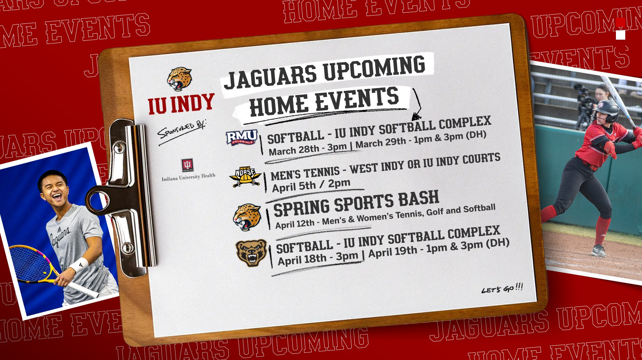

# Agenda Item VII: Report from Vice Chancellor for Finance & Administration

# Camy Broeker, *Vice Chancellor, Finance & Administration*, [cbroeker@iu.edu](mailto:cbroeker@iu.edu)

# Camy relinquished her time to ensure sufficient time for presentations, but did accept questions.

# Agenda Item VIII: Report from Human Resources

Anne Mitchell, *Senior Human Resources Director,* [amitch29@iu.edu](mailto:amitch29@iu.edu)

Anne shared the following updates:

* Women’s history month
* Disability awareness month – second year doing it on campus
  + Keep mobility in mind around campus
* Staffing updates:
  + HR Coord in School of Dentistry is open. Previous incumbent, Deep Kaur, got promoted to HR Generalist in the School of Dentistry.
  + Two staffing changes at the campus level:
    - Janice Blum is retiring on June 30th
    - PJ Woolston has also resigned. Going to the Lumen Foundation. Rebecca Ellis will be the interim VC of Enrollment
* Awards Bruncheon coming up – April 8th
* Staff Welcome: Starting in 2 weeks for all new hires since January 1. The event aims to orient new staff to campus traditions, history, leadership, and resources. The frequency of these events is yet to be decided (every 2 months or quarterly). IUSM has its own welcome program. The goal is for attendees to leave knowing their HR contact and a peer from their cohort.
  + The welcome sessions are not recorded yet; they plan to conduct a few sessions before considering recording.
  + This welcome does not replace IUHR’s presentation on public safety, OIE, or benefits, which remain available online. Public safety information is included in the slides.
* Performance at IU calendar
  + Reviews should be happening now; Expectation conversations should be happening soon.
* My Voice has rolled out to HRBPs.
* Admin reviews for 2 people (Kristi Palmer, Rafael Bahamonde) are happening through the president’s office now
  + Question – are there anonymized surveys? Anne said – historically, but since it is now run by the President’s office, not positive.
* Met with the Staff Affairs subcommittee, along with Gretchen Dennis and Joe Farrell, to discuss their questions

# Agenda Item IX. Update from Faculty Council

# Lisa Angermeier, *Faculty Council Liaison*, [langerme@iu.edu](mailto:langerme@iu.edu)

# Lisa was unable to attend but provided the following report.

# Tom Stucky has initiated a campuswide conversation called “Forging an IU Indianapolis Identity.”

# Initial proposal discussed

* A shared identity gives us a reason to be/helps us chart our way through rough seas.
* Otherwise, we simply react to the next iceberg that floats at us.
* To articulate/reinforce/reinvigorate this shared identity, we propose a joint set of discussions among stakeholders.

Suggestions for the Process

* Probably need to get fears out before getting to hopes/aspirations
* Gather existing statements – learning from the past to guide the future
* Conduct a short survey and focus groups of stakeholders
* Involve stakeholder group leaders ASAP
* Consider the creation of a task force
* Identify benchmarks or milestones
* Public timeline of activities and periodic reporting on progress

# Please reach out to Tom Stucky ([tstucky@iu.edu](mailto:tstucky@iu.edu)) to participate in this process, if you have not already done so.

# Agenda Item X: [Action Item] Approval of Minutes of the February 19, 2025, SC Meeting

# Heather Staggs

# With no objections, the February 19 SC meeting minutes were approved.

**Agenda Item XI: Question and Answer Period**

# None

# Agenda Item XII: Unfinished Business

# None

# Agenda Item XIII: New Business

None

# Agenda Item XIV: [Action Item] Final Remarks and Adjournment

# Heather Staggs

# The meeting was adjourned. The next Staff Council meeting will be April 16, 2025 Campus Center 309 or via Zoom.

**Committee Reports:**

|  |
| --- |
| **Awards and Recognitions Committee:**  Nominations for Staff Council awards have been reviewed and awardees identified. Recipients will be recognized at an upcoming brunch on April 8. |
| **Bylaws Committee:**  Proposed bylaws changes with elimination of President-Elect and revised terms for Officer eligibility reviewed with executive committee. First-read with SC representatives will be at March 19 Staff Council meeting. |
| **Communications Committee:**  Promoted Staff Council awards and promoting upcoming blood drive. |
| **DEI Committee:**  Discussing committee description with members of Staff Council executive council. |
| **Staff Development Committee:**  Next deadline for professional development grants is April 1st. A new submission process will be in place for August deadline.  Deadline for mini-conference proposals was February 28. |
| **Special Events Committee:**  Planning for retreat is progressing. Location identified, keynote, breakouts and food being discussed.  Blood drive March 26, 10 a.m.- 4 p.m., Campus Center Atrium. Register at: <https://donateblood.versiti.org/donor/schedules/drive_schedule/11606228> |
| **Staff Affairs Committee:**  Meeting with IUI HR leaders over IUI, IUSM, and UA was held to discuss constituent questions/provide feedback. |
| **Sustainability Committee:**  Greening IUI Grant deadline pushed back to April 6. Submitting proposal for clean-up kits for green teams and tree tender group. Stuff Swap is April 16. Sustainable Swag Guide popular; sent out through staff email list. |
| **Ad Hoc Committees:** |