

# Staff Council Minutes November 20, 2024 ~ 2:00-4:00 p.m.

**Campus Center 309 or Zoom**

**Members and Guests Present:** Sadiya Ali, Connie Anoskey, Jesse Beck, Chad Beckner, Thora Berndt, Brayden Bridgeman, Aaron Buck, Beth Chaisson, Crystal Clark, Mindy Cooper, Jeff Dawn, Melissa Decker, Brandi Derrick, Natasha Dow, Tricia Edwards, Connie Ely, Ailish Evans, Kevin Fryling, Alicia Gahimer, Jennifer Gilles, Roland Graham, Lauren Gronke, Nick Hyllested, Kim Johnson, LaVerne Johnson, Madi Jones, Tammy Leone, Natalie Lin, Jennifer McChristian, Anne McGee, Mercedes O’Connor-Gosser, Charlotte Pell, Amber Phillips, Kris Powell, Jamunabai Prakash, Matthew Radican, Summer Rozear, Anita Sale, Linsday Sanner, Anita Snyder, Heather Staggs, Yolanda Taylor, Heather Wagoner, Dillon Waggoner, Jordan Wheatley, Katie Wilkinson, Catherine Zappia, Andrea Zeek, Lisa Angermeier, Camy Broeker, Sarah Frigo, Jennifer Mahoney, Anne Mitchell, Olivia Stoner, Sara Whitacre, Cedric Morrison, Melissa Vastag, Sabrina Hetzel, Sarah Whitacre, Elisa Seidel, Joe Hayes, Anne Angermeier

**Members Excused:** Ryan Schafer, Paige Smith, Laurie Welty, Todd Kirk

**Members Absent:** Alan Beard, Todd Grooten, Robyn Hart, Huma Siddiqui, Emily Skonieke

# Agenda Item I: Welcome and Call to Order

Heather Staggs, *President*, [hstaggs@iu.edu](mailto:hstaggs@iu.edu)

IU Indianapolis Staff Council President Heather Staggs called the meeting to order.

# Agenda Item II: [Action Item] Adoption of the Order of Business for the Day

Heather Staggs

The agenda was adopted as the Order of Business for the Day.

# Agenda Item III: [Action Item] Approval of Minutes of the October 16, 2024, SC Meeting

Heather Staggs

With no objections, the October 16 SC meeting minutes were approved.

# Agenda Item IV: Report from the President

Heather Staggs

* Dec 2 is the next deadline for the staff council professional grants.
* The next blood drive is Nov. 26 in the campus center atrium from 10 am – 4 pm.
* We participated in the United Way Spooktacular event. It was nice to have Staff Council there to represent and learn more about opportunities with the United Way.
* Professional development opportunities from IUI Events Calendar
  + November 21 – Service to Honor Grief and Pain During the Holidays; Road to Retirement Series; CareTalks; Performance at IU Annual Conversation Trainings; Financial Wellness
  + December 3 – Herron Winter Market; Road to Retirement- 4pm on Zoom
  + December 4 – Brand Education Workshop: Make the Most of Your Content –

CE 307 11:00am-12:30pm

* + December 5 – CareTalks Emotional Wellness and Forgiveness- 1-2pm on Zoom
  + December 10 – CareTalks Disability & Neurodiversity 1-2pm; Performance at IU training for staff 2-3pm
  + December 11 – Financial Wellness 12-1pm
* Athletics calendar
  + November 21-23 M/W Swimming & Diving House of Champions / Natatorium
  + November 30 2pm Men’s Basketball / The Jungle
  + December 4 6:30pm / Men’s Basketball / The Jungle / Note: RED OUT
  + December 7 2pm / Men’s Basketball / The Jungle
  + December 11 6:30pm / Women’s Basketball / The Jungle
* We celebrated all those who achieved major milestones 20+ years and up at the IU Indianapolis Long-Service Recognition Event on November 13.
* New Staff Council Zoom Backgrounds available!!
* Staff Council is sponsoring a family for the holiday season.
  + Amazon: <https://www.amazon.com/hz/wishlist/ls/277JQ2QJES3XB?ref_=wl_share>
  + Thank you to Connie Anoskey for helping wrap and deliver gifts.
* November 2024 Staff Milestones Recognition
  + 5 years – 20 people
  + 10 years – 15 people
  + 15 years – 7 people
  + 20 years – 6 people
  + 25 years – 4 people
  + 30 and 35 years – 3 people
* The January Staff Council meeting will be attended by Chancellor Latha Ramchand and Provost Jay Gladden. There will be no zoom option.

# Agenda Item V: Update from the Vice Chancellor for Finance and Administration

Camy Broeker, *Vice Chancellor for Finance and Administration,* [cbroeker@iu.edu](mailto:cbroeker@iu.edu)

* There are updates to the shuttle service to ensure broader access, especially to the area on Michigan St. by Kroger and the Health Center. This also helps connect us better to the Red Line. Please look into updated shuttle service.
* Construction updates:
  + New arena will be breaking ground in the Spring. Goal is to be completed in 2026. The new arena will be named after James Morris, a staunch advocate for sports in Indianapolis and IU Indianapolis broadly. It will be referred to as “the Jim.”
  + New research building will begin construction in the spring as well.
  + Purdue University will be breaking ground on their new building (at the corner of West and Michigan – in the parking lot across from ICTC).
* Bike pathway is still ongoing – up to the City, not IU.

# Agenda Item VI: Report from Human Resources

Anne Mitchell, *Senior Human Resources Director,* [amitch29@iu.edu](mailto:amitch29@iu.edu)

* November is Native American Heritage month, Veterans Day, and Thanksgiving holiday. Thank you to all who came out for the Veterans celebration as our veteran employees walked through campus to the city’s veterans’ parade.
* Thank you to everyone who came to celebrate our staff who were recognized at the Long Service Program on November 13. Thanks to Heather for emceeing the event. It was nice to pause and remember all staff do to help the campus shine.
* MyVoice survey collection is completed. Thanks for making your voice heard. Results are forthcoming.
* School of Nursing Dean search is in progress. HR has a few searches as well:
  + HR Generalist (posted)
  + HR Coordinator (closed, interviewing)
  + Project Management Specialist (closed, Olivia Stoner hired)
  + Project Management Coordinator (closed, interviewing) – this position will support staff engagement events & staff council. Thanks to Heather for serving on the search committee.
* The change to the FLSA salary threshold has been halted by a federal judge. No changes to salary or job classification related to the FLSA overtime rule will be implemented as a result.

# Agenda Item VII: [Information Item] Faculty Council Updates

Lisa Angermeier, *Faculty Council Liaison*, [langerme@iu.edu](mailto:langerme@iu.edu)

* A Memorial Resolution for Janice C. Froehlich, Chancellor’s Professor, School of Medicine, was read and placed into the record at the IFC meeting on November 19, 2024.
* COACHE Survey at IU Indy - Margie Ferguson, Senior Associate Vice Chancellor for Academic Affairs
  + Nationwide survey of faculty satisfaction
  + The first time IU Indy has participated in it.
  + Links on the Office of Academic Affairs website
    - <https://academicaffairs.indianapolis.iu.edu/Strategic-Initiatives/coache>
    - [IU Indy Summary Report](https://indiana.sharepoint.com/sites/msteams_a13432/Shared%20Documents/Forms/AllItems.aspx?id=%2Fsites%2Fmsteams%5Fa13432%2FShared%20Documents%2FGeneral%2FCOACHE%2FCOACHE%5FPreviewReport%5F2024%5FIUPUI%20Public%2Epdf&parent=%2Fsites%2Fmsteams%5Fa13432%2FShared%20Documents%2FGeneral%2FCOACHE&p=true&ga=1)
    - [School-Level Dashboard](https://tableau.bi.iu.edu/%23/site/prd/views/COACHESurvey/ReadMe?%3Aiid=1&%3Aredirect=auth&_gl=1%2Aobpbfh%2A_gcl_au%2ANzcyMDg0MzUwLjE3Mjk3Njc0Mjg.%2A_ga%2AMTc2OTMzNjc1OS4xNzA3OTQ4MDE4%2A_ga_61CH0D2DQW%2AMTczMjA0ODA0OS41MC4xLjE3MzIwNDgxMjQuNjAuMC4w)
* Reimagining Democracy Plaza – Eric Weldy, Vice Chancellor for Student Affairs, and Precious Majors, Assistant Director of the Social Justice Education Program
  + Chalkboard in breezeway under BS building and in Campus Center
  + Provides an opportunity for the campus community to express, speak, and hear diverging thoughts surrounding social, political, economic, and other issues relevant to the campus, city, state, country, and world.
  + The Task Force will be working through the spring semester and will be responsible for proposing a new format or structure for both locations.
* SEA 202 Policy Drafts – Willie Miller, Assistant Vice Chancellor for Faculty Affairs
  + Three documents were discussed for a first read to ensure we are complying with SEA 202
    - Intellectual Diversity Review
    - Procedures for Intellectual Diversity Complaints
    - IU Indianapolis Promotion and Tenure Guidelines
  + Second reading and a possible vote at the next IFC meeting

# Agenda Item VIII: [Information Item] Master of Jurisprudence Program

Elise Seidel, Recruiter of Graduate and International Programs

* MJ program is designed for individuals interested in developing a better understanding of the law but who do not wish to practice law
* Customizable curriculum to serve your needs / courses in multiple areas of law
  + 30 credit hours (FT and PT options)
  + 6-8 credits mandatory
  + 22-24 credits are electives
  + Primarily in person with online course options
  + Dual-degree options
* Alumni have careers in a variety of fields, including finance, compliance, HR, police, business, education and more.
* Application – Opens 9/1 and closes 4/1
* Cost of attendance - $1008 per credit course/ IU tuition benefit applicable

# Agenda Item IX: Standing, Ad Hoc, and University Committee Reports

Thank you to the Special Events Committee for hosting cider and hot chocolate at this meeting.

It was especially good because it was the first snow!

# Awards and Recognitions Committee:

Reviewing scoring grids for Staff Council Awards and Glenn W. Irwin Award criteria.

# Bylaws Committee:

Reviewing bylaws comments and explanations for revising and presenting revisions to council when appropriate.

# Communications Committee:

Promoting the November blood drive and December professional development grant through various communication channels: social media, IUI Today articles, Events Calendar, etc.

# Staff Development Committee:

The next professional development grant deadline is December 2, 2024.

Plan to finalize the theme for the Staff Development mini conference this month. Anticipate sending out calls for proposals in early December with reminders being sent late January and another at a future date to be determined based on responses.

# Special Events Committee:

Secured beverage bar for November meeting. Planning for the December meeting. Preparing for November blood drive, working with Communications Committee to promote. Considering how Staff Council can support schools/departments for Volunteer Day. Re-introducing Guess Who to begin at November Staff Council meeting.

**Sustainability Committee:** Working on swag guidelines with the Office of Sustainability. We are going to be meeting on November 22nd to finalize the guidelines. Once the guidelines are ready, they will be shared to solicit feedback.

# Ad Hoc Committees:

Bookstore Advisory Board

* Renovations are complete.
* Sales for textbooks went up 5%.
* They will participate in a select number of women’s basketball games in the coming months to offer apparel.
* Promotions and store photos:

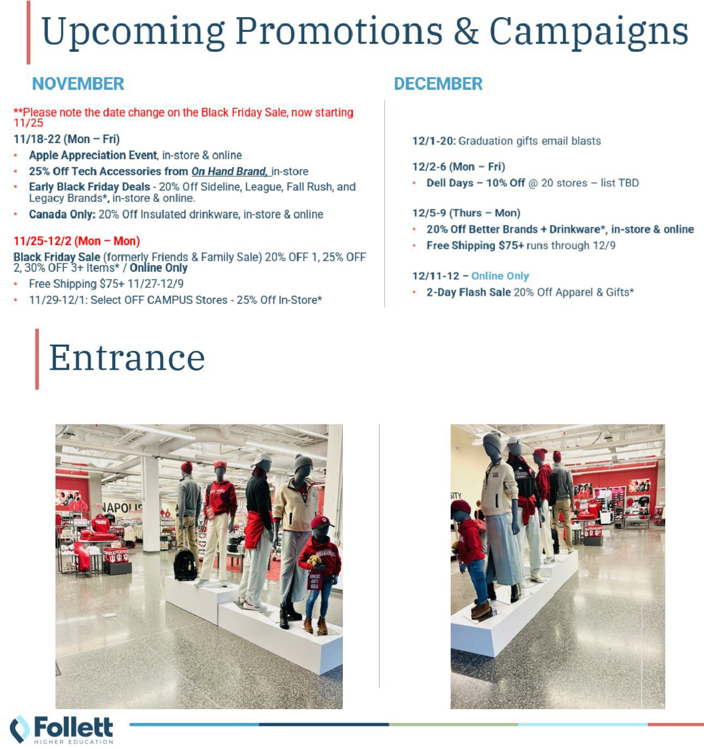

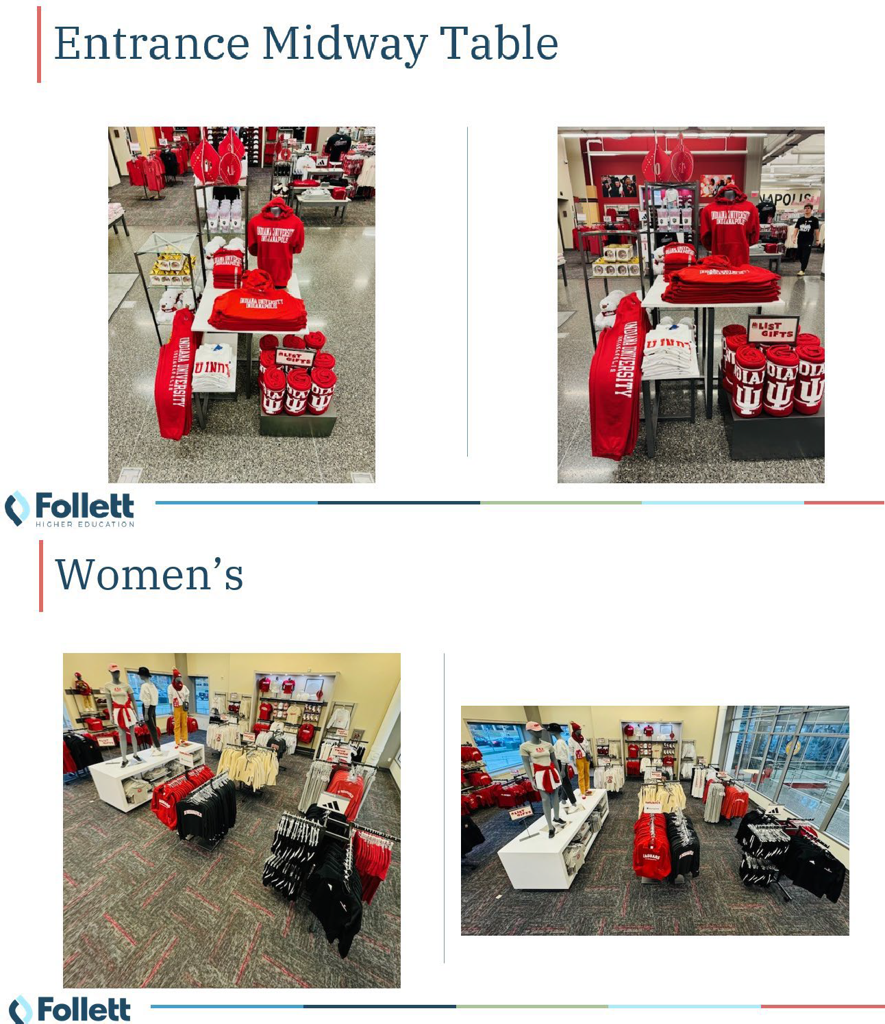

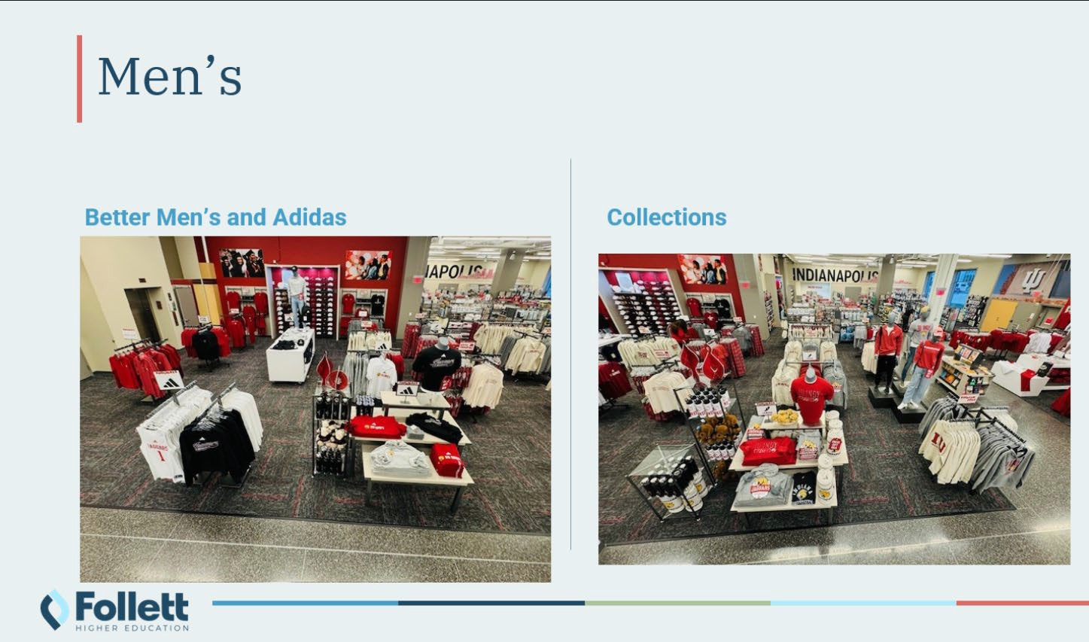

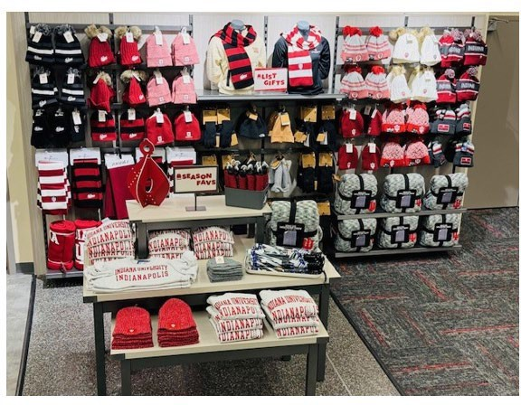

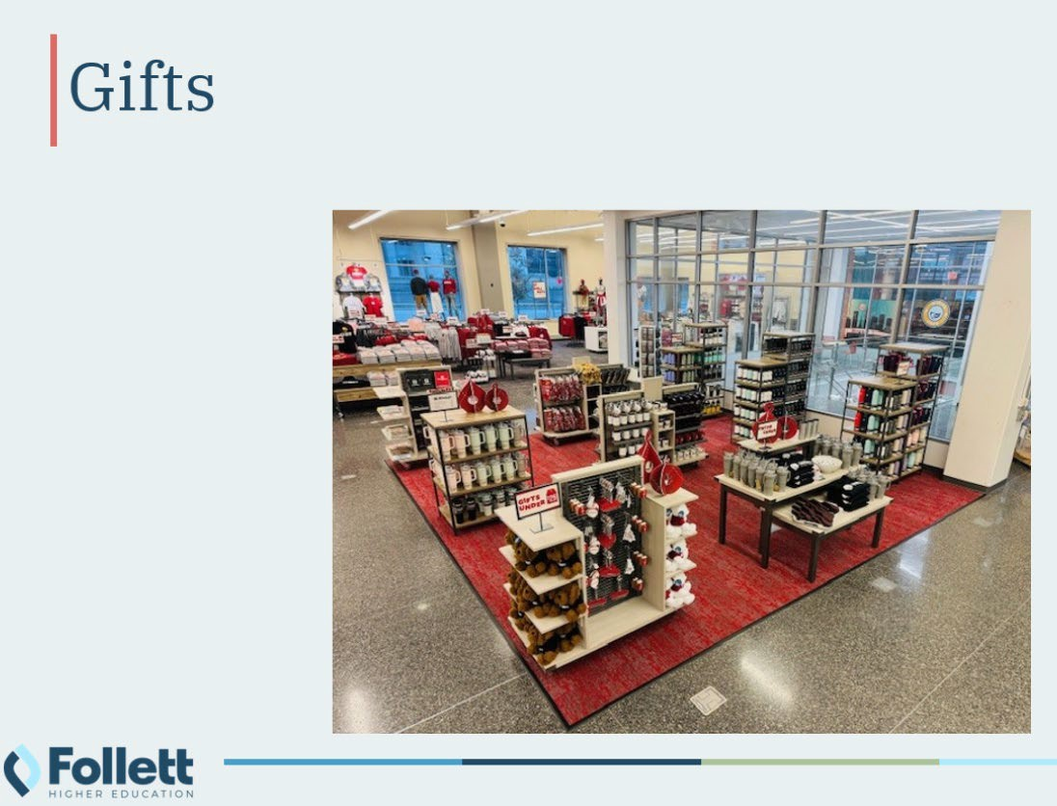

# Agenda Item X: [Information Item] Veterans Faculty and Staff Council

Joe Hayes, Campus Center Director and Chair of the VFSC

* Veterans Faculty and Staff Council is one of many faculty and staff councils in place to be a resource to employees.
* Social events twice a month (one brown bag lunch during work and one after work social)
* Listserv – please contact the Veterans Faculty Staff Council ([vfsc@iu.edu](mailto:vfsc@iu.edu)) to be added to the listserv
* We celebrate Veterans Day (march and flag raising ceremony) annually and do so in conjunction with the Office of Veteran and Military Personnel within the Division of Enrollment Management
* Please know you can always reach out and we’d love to be connected with you

# Agenda Item XI: Guess Who

Tricia Edwards, Vice President

Tricia led us through information about five staff council representatives so we can get to know a little bit about each other.

# Agenda Item XII: Question and Answer Period

None

# Agenda Item XIII: Unfinished Business

None

# Agenda Item XIV: New Business

None

# Agenda Item XIII: [Action Item] Final Remarks and Adjournment

Heather Staggs

The meeting was adjourned. The next Staff Council meeting will be December 18, in Campus Center 309 or on Zoom, [**https://iu.zoom.us/j/84849043840**](https://iu.zoom.us/j/84849043840)